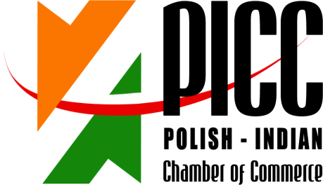

REGISTRATION FORM
INDIA-POLAND COOPERATION & INVESTMENTS: MANUFACTURING, ENGINEERING & ALLIED SECTORS SEMINAR + B2B MEETINGS

3 JUNE 2014, 15.30 – 18.30 hrs
POZNAN INTERNATIONAL FAIR
PAVILLON 15, HALL 1A and 1B

Imię i Nazwisko/ RepresentativeName: | V.Saravanakumar
Stanowisko / Designation: | Managing Partner
Firma/ Company Name: | Sri Saravanaa Fabs
Adres/Address: | 391/4, 2nd Street , Nehrunagar west, Coimbatore- 641014
Numer telefonu/  Telephone number: | +914226541425 Mobile +919843126270, +919843326270
www: | ssfabs.in ssfass.com | E-mail: | ssfabs@gmail.com , ceossfabs@gmail.com
Krótkainformacjant. działalnościfirmy/ Brief Company Profile: | Our Company is Started in 1997, Doing Sheetmetal Fabrication in MildSteel, Stainless Steel, Aluminium.Having Latest Technology Machines, Such as Lasercutting,CNC Turret Punching, Bending Machines
Propozycjabiznesowa /  Brief information on business proposal: | Technical Tieup , Product Tieup , Technology Transfer, Exclusive Production Base in India . Kitchen Equipments, Modular Furnitures, Machinary Enclosures, Electrical & Electronic Enclosures ,Stainless Steel Enclosurers & Panels , Windmill Solar Panels & Parts , Tool Trolleys , Information Kiosks , Conveyor Accessories , Material Handling Equipments
Chcielibyśmy odbyć spotkanie z następującymi firmami /
We would like to meet with representatives of the following companies:

Please return this form preferably in word format by return email by 8th May 2014:

Ms. Anna Kobierska
Polish-Indian Chamber of Commerce
Bukowska 12
World Trade Center building
Poznan International Fair
60-810 Poznan
tel: + 48 (61) 865 38 23
E-mail: anna.kobierska@piig-poland.org, Klaudia.gostynska@piig-poland.org & mark a copy to nchoudhury@eepcindia.net

