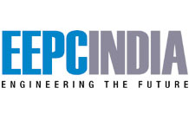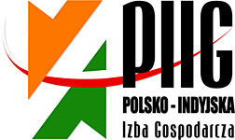

INDIA-POLAND COOPERATION & INVESTMENTS: MANUFACTURING, ENGINEERING & ALLIED SECTORS SEMINAR + B2B MEETINGS

3 JUNE 2014, 15.30 – 18.30 hrs
POZNAN INTERNATIONAL FAIR
PAVILLON 15, HALL 1A and 1B

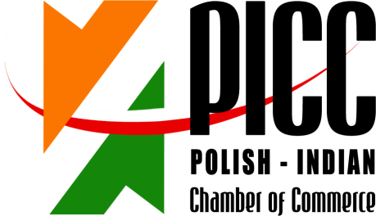

INDIA-POLAND COOPERATION & INVESTMENTS: MANUFACTURING, ENGINEERING & ALLIED SECTORS SEMINAR + B2B MEETINGS

3 JUNE 2014, 15.30 – 18.30 hrs
POZNAN INTERNATIONAL FAIR
PAVILLON 15, HALL 1A and 1B

15.30 – 15.35 Welcome address by Mr Ryszard Sznajder, President of the Board, Polish-Indian Chamber of Commerce;
15.35 – 15.40 Welcome address by Mr Jerzy Pietrewicz, Secretary of State, Ministry of Economy;
15.40 – 15.50 Keynote address by Mr. Rajeev Kher, Commerce Secretary, Ministry of Commerce and Industry, Govt. of India (to be confirmed by EEPC)
15.50 – 15.55 Address by Mr. Ravi Capoor, Joint Secretary, Ministry of Commerce & Industry, Government of India
15:55 – 16:00 Mr. Anupam Shah, Chairman, EEPC India, Leader of the Business Delegation, Engineering Export Promotion Council
16.00 – 16.15 Economic situations and development prospects of Poland, Chief Economist, PKO Bank Polski (the biggest Polish Bank)
16:15 – 16.30 Von Zanthier& Schulz - Investment climate in Poland – business opportunities for Indian companies. Investing in and trading with Poland – tax and legal aspects
16:30 – 16.40 INVEST India
16.40 – 17.00 Success case – Poland-India business cooperation
- Flex Films Europa Ltd. (Uflex Group)
17.00 – 17.10 Question & Answer Session
17.10 – 17.20 Signing of MoU Between Invest India & Invest Poland

REGISTRATION FORM
INDIA-POLAND COOPERATION & INVESTMENTS: MANUFACTURING, ENGINEERING & ALLIED SECTORS SEMINAR + B2B MEETINGS

3 JUNE 2014, 15.30 – 18.30 hrs
POZNAN INTERNATIONAL FAIR
PAVILLON 15, HALL 1A and 1B

Imię i Nazwisko/ RepresentativeName: | Mr. Atul Shah
Stanowisko / Designation: | Director
Firma/ Company Name: | SENOR METALS PVT. LTD.
Adres/Address: | Plot-353, GIDC-II, Dared,  JAMNAGAR – 361004 Gujarat State [INDIA]
Numer telefonu/  Telephone number: | +91-288-2730251/252/253 Fax # +91-288-2730254
 |  | E-mail: | info@senormetals.in;  atul@senormetals.in  www.senormetals.in
Krótkainformacjant. działalnościfirmy/ Brief Company Profile: | Manufacturers of Copper & Copper Base Alloys Brazing and Welding Wires ,Resistance Welding Products, Aluminum Alloys Brazing and Metalizing Products ,EDM Wires, High Copper Alloys like Chromium Copper, Chromium Zirconium Copper, Cadmium Copper, Tellurium copper, Sulphur Copper, Copper Nickel Alloys and Components made from these alloys, Extruded Rods, Profiles, Tubes, Wires , Wires for Miniature Precision Turned Components, Fastener wires, Ingots, Centrifugal Castings , and Components
Propozycjabiznesowa /  Brief information on business proposal: | We are searching for Distributors or Dealers and Institutional  Buyers for our welding and Brazing products and other products’listed above.
Chcielibyśmy odbyć spotkanie z następującymi firmami /  We would like to meet with representatives of the following companies: | 1)Distributors or Dealers of Welding and Brazing Products  2)Automotive Companies Purchase representatives  3)Any other comannies who have interest in our products
This to be without any financial obligation on our Company i.e Senor Metals Pvt Ltd

Please return this form preferably in word format by return email by 8th May 2014:

Ms. Anna Kobierska
Polish-Indian Chamber of Commerce
Bukowska 12
World Trade Center building
Poznan International Fair
60-810 Poznan
tel: + 48 (61) 865 38 23
E-mail: anna.kobierska@piig-poland.org, Klaudia.gostynska@piig-poland.org & mark a copy to nchoudhury@eepcindia.net

