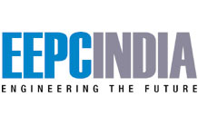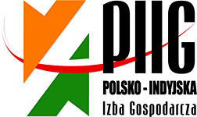

INDIA-POLAND COOPERATION & INVESTMENTS: MANUFACTURING, ENGINEERING & ALLIED SECTORS SEMINAR + B2B MEETINGS

3 JUNE 2014, 15.30 – 18.30 hrs
POZNAN INTERNATIONAL FAIR
PAVILLON 15, HALL 1A and 1B

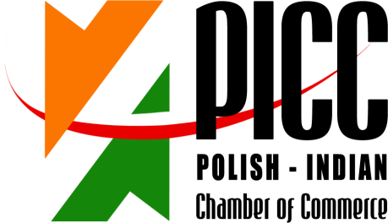

INDIA-POLAND COOPERATION & INVESTMENTS: MANUFACTURING, ENGINEERING & ALLIED SECTORS SEMINAR + B2B MEETINGS

3 JUNE 2014, 15.30 – 18.30 hrs
POZNAN INTERNATIONAL FAIR
PAVILLON 15, HALL 1A and 1B

15.30 – 15.35 Welcome address by Mr Ryszard Sznajder, President of the Board, Polish-Indian Chamber of Commerce;
15.35 – 15.40 Welcome address by Mr Jerzy Pietrewicz, Secretary of State, Ministry of Economy;
15.40 – 15.50 Keynote address by Mr. Rajeev Kher, Commerce Secretary, Ministry of Commerce and Industry, Govt. of India (to be confirmed by EEPC)
15.50 – 15.55 Address by Mr. Ravi Capoor, Joint Secretary, Ministry of Commerce & Industry, Government of India
15:55 – 16:00 Mr. Anupam Shah, Chairman, EEPC India, Leader of the Business Delegation, Engineering Export Promotion Council
16.00 – 16.15 Economic situations and development prospects of Poland, Chief Economist, PKO Bank Polski (the biggest Polish Bank)
16:15 – 16.30 Von Zanthier& Schulz - Investment climate in Poland – business opportunities for Indian companies. Investing in and trading with Poland – tax and legal aspects
16:30 – 16.40 INVEST India
16.40 – 17.00 Success case – Poland-India business cooperation
- Flex Films Europa Ltd. (Uflex Group)
17.00 – 17.10 Question & Answer Session
17.10 – 17.20 Signing of MoU Between Invest India & Invest Poland

REGISTRATION FORM
INDIA-POLAND COOPERATION & INVESTMENTS: MANUFACTURING, ENGINEERING & ALLIED SECTORS SEMINAR + B2B MEETINGS

3 JUNE 2014, 15.30 – 18.30 hrs
POZNAN INTERNATIONAL FAIR
PAVILLON 15, HALL 1A and 1B

Imię i Nazwisko/ RepresentativeName: | PRASAD G PIMPLE
Stanowisko / Designation: | SR. EXECUTIVE
Firma/ Company Name: | ROYAL ARC ELECTRODES LIMITED
Adres/Address: | 203 TO 205, BUSINESS CLASSIC, OPP. SEKSARIA INDL. ESTATE. CHINCHOLI BUNDER ROAD, MALAD (WEST),  MUMBAI 400064, MAHARASHTRA, INDIA
Numer telefonu/  Telephone number: | 0091-22-2882 2374 / 2882 0328
www.royal-welding.com |  | E-mail: | exim@royalarc.in & royalarc@vsnl.com
Krótkainformacjant. działalnościfirmy/ Brief Company Profile: | ROYAL ARC ELECTRODES, an ISO: 9001-2008 certified company; welds the world with new technologies. We are one of the leading manufacturers of Welding Electrodes, Mig/Tig Wires, Flux Cored Wires and Abrasive wheels for Grinding & Cutting. Our several products are approved by LRS ABS, DNV, BV & GL Qatar Petroleum & Kuwait Petroleum and many other renowned inspection organisation.  We have served different sectors and fields such as Railways, Shipyards, Refineries, Nuclear Power projects, Cement & Mining Industry & Defense in our country and abroad  We exports to more than 45 countries worldwide. We are regularly supplying to appointed dealers and the continuous business for our products from so many countries proves that our product is giving satisfactory performances to customers and users.
Propozycjabiznesowa /  Brief information on business proposal: | We are looking for Collabration with company who are into Welding Business or Distributor in Poland
Chcielibyśmy odbyć spotkanie z następującymi firmami /  We would like to meet with representatives of the following companies: | - Welding Electrodes & Welding Wires Manafacturer  - Engieering Companies  - Distributor of Welding & Welding Wires

Please return this form preferably in word format by return email by 8th May 2014:

Ms. Anna Kobierska
Polish-Indian Chamber of Commerce
Bukowska 12
World Trade Center building
Poznan International Fair
60-810 Poznan
tel: + 48 (61) 865 38 23
E-mail: anna.kobierska@piig-poland.org, Klaudia.gostynska@piig-poland.org & mark a copy to nchoudhury@eepcindia.net

