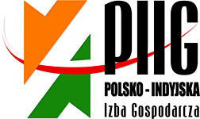

INDIA-POLAND COOPERATION & INVESTMENTS: MANUFACTURING, ENGINEERING & ALLIED SECTORS SEMINAR + B2B MEETINGS

3 JUNE 2014, 15.30 – 18.30 hrs
POZNAN INTERNATIONAL FAIR
PAVILLON 15, HALL 1A and 1B

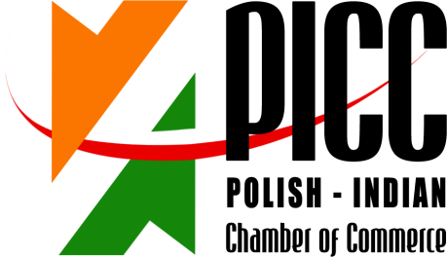

INDIA-POLAND COOPERATION & INVESTMENTS: MANUFACTURING, ENGINEERING & ALLIED SECTORS SEMINAR + B2B MEETINGS

3 JUNE 2014, 15.30 – 18.30 hrs
POZNAN INTERNATIONAL FAIR
PAVILLON 15, HALL 1A and 1B

15.30 – 15.35 Welcome address by Mr Ryszard Sznajder, President of the Board, Polish-Indian Chamber of Commerce;
15.35 – 15.40 Welcome address by Mr Jerzy Pietrewicz, Secretary of State, Ministry of Economy;
15.40 – 15.50 Keynote address by Mr. Rajeev Kher, Commerce Secretary, Ministry of Commerce and Industry, Govt. of India (to be confirmed by EEPC)
15.50 – 15.55 Address by Mr. Ravi Capoor, Joint Secretary, Ministry of Commerce & Industry, Government of India
15:55 – 16:00 Mr. Anupam Shah, Chairman, EEPC India, Leader of the Business Delegation, Engineering Export Promotion Council
16.00 – 16.15 Economic situations and development prospects of Poland, Chief Economist, PKO Bank Polski (the biggest Polish Bank)
16:15 – 16.30 Von Zanthier& Schulz - Investment climate in Poland – business opportunities for Indian companies. Investing in and trading with Poland – tax and legal aspects
16:30 – 16.40 INVEST India
16.40 – 17.00 Success case – Poland-India business cooperation
- Flex Films Europa Ltd. (Uflex Group)
17.00 – 17.10 Question & Answer Session
17.10 – 17.20 Signing of MoU Between Invest India & Invest Poland

REGISTRATION FORM
INDIA-POLAND COOPERATION & INVESTMENTS: MANUFACTURING, ENGINEERING & ALLIED SECTORS SEMINAR + B2B MEETINGS

3 JUNE 2014, 15.30 – 18.30 hrs
POZNAN INTERNATIONAL FAIR
PAVILLON 15, HALL 1A and 1B

Imię i Nazwisko/ RepresentativeName: | AKASH RANKA
Stanowisko / Designation: | MANAGER MARKETING
Firma/ Company Name: | PARAMOUNT INDUSTRIES
Adres/Address: | NO.70, 5TH CROSS, S.S.I AREA RAJAJINAGAR, BANGALORE 560010
Numer telefonu/  Telephone number: | +91-80-22970010
www: | www.paramount.net.in | E-mail: | akash@paramount.net.in
Krótkainformacjant. działalnościfirmy/ Brief Company Profile: | MANUFACTURER OF ELECTROMECHANICAL RELAYS, SOLID STATE RELAYS, DIODE ORING MODULES, HOOTERS, BUZZZERS, SWITCHES SINCE 1973 IN BANGALORE INDIA
Propozycjabiznesowa /  Brief information on business proposal: | LOOKING FOR JOINT PARTNERS IN POLAND TO INCREASE THE MARKET SHARE IN EUROPE WITH POLAND AS HUB.
Chcielibyśmy odbyć spotkanie z następującymi firmami /  We would like to meet with representatives of the following companies: | As recommended by Polish Indian Chamber of commerce

Please return this form preferably in word format by return email by 8th May 2014:

Ms. Anna Kobierska
Polish-Indian Chamber of Commerce
Bukowska 12
World Trade Center building
Poznan International Fair
60-810 Poznan
tel: + 48 (61) 865 38 23
E-mail: anna.kobierska@piig-poland.org, Klaudia.gostynska@piig-poland.org & mark a copy to nchoudhury@eepcindia.net

