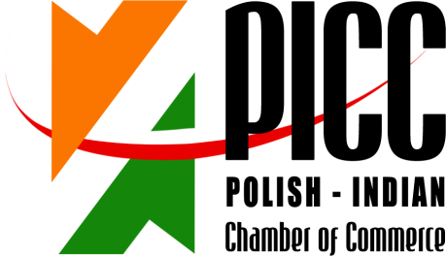

REGISTRATION FORM
INDIA-POLAND COOPERATION & INVESTMENTS: MANUFACTURING, ENGINEERING & ALLIED SECTORS SEMINAR + B2B MEETINGS

3 JUNE 2014, 15.30 – 18.30 hrs
POZNAN INTERNATIONAL FAIR
PAVILLON 15, HALL 1A and 1B

Imię i Nazwisko/ RepresentativeName: | Dr.H Sundara Murthy. PhD ( IISc)
Stanowisko / Designation: | Proprietor
Firma/ Company Name: | Fenfe Metallurgicals.  No.2,SyNo.20-A,Uttrahalli,Bangalore -560 061.
Adres/Address: | Plot No.347 A, 2nd Phase,KIADB Industrial Area,Harohalli 562112 Kanakapura Taluk Ramanagra District.
Numer telefonu/  Telephone number: | 080-41632962 /26396461,Mobile + 919845011461, 9199456 95322
www: | fenfemetallurgiclas.com met@gmai.comm | E-mail: | fenmet@gmail.com
Krótkainformacjant. działalnościfirmy/ Brief Company Profile: | Technically Leading Foundry producing High quality castings in Alminium alloys. It supplies the requirements of electrical, Machine tool, Power transmission industry, Power generation and high torque coupler manufactures, high precision and defence items.
Propozycjabiznesowa /  Brief information on business proposal: | Companies interested in Joint Venture Development in production of  Large Aluminium alloy Castings for industrial applications,Aerospace  & Defence applictions.
Chcielibyśmy odbyć spotkanie z następującymi firmami /  We would like to meet with representatives of the following companies: | - Consumers of large Aluminium alloy Castings.  - Foundries Producing Aluminium alloy Castings interested in expanding their actvities in India.  - Aerospace casting development

Please return this form preferably in word format by return email by 8th May 2014:

Ms. Anna Kobierska
Polish-Indian Chamber of Commerce
Bukowska 12
World Trade Center building
Poznan International Fair
60-810 Poznan
tel: + 48 (61) 865 38 23
E-mail: anna.kobierska@piig-poland.org, Klaudia.gostynska@piig-poland.org & mark a copy to nchoudhury@eepcindia.net

